DBMS Lab Assignment 2
Neeti Kurulkar
Design and develop SQL statements which demonstrate the use of SQL object such as Table, View, Index, Sequence, Synonym and Various Constraints etc

Queries:
- Create DEPT and EMP tables with given constraints

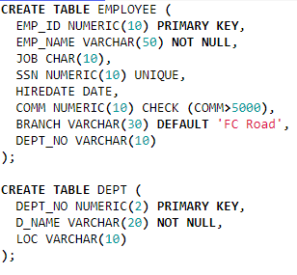

- Insert records into table

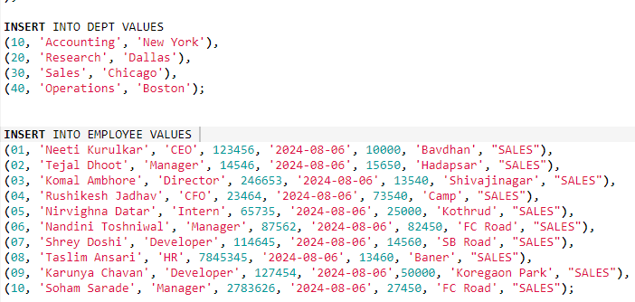

- Alter table EMP to add new column Salary

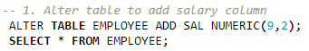

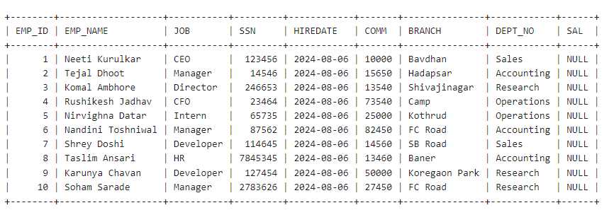

- Create Unique Index on SSN field of the EMP table.



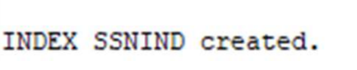

- Create a View on EMP table

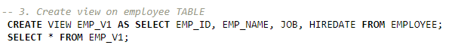

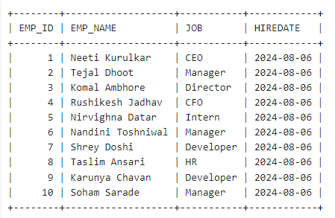
- Create a SEQUENCE by the name SEQ, which will generate numbers from 1 to 25 in ascending order with an interval of 1. The sequence must restart from 1 after generating number 25. Insert the SEQ values in column code.

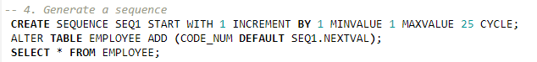

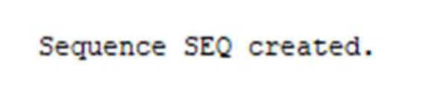

- Create Synonym for table DEPT.

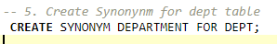

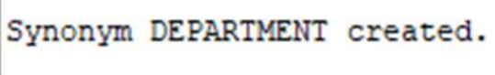

- Drop Primary Key constraint on DEPT table.

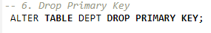

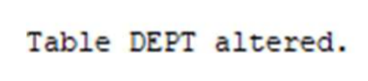

- For DEPT table create Composite Primary Key as DEPTNO and DNAME

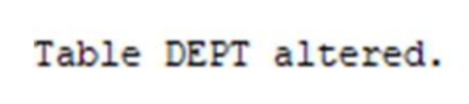

- Modify size of field BRANCH in table EMP

